**Hisense unveils PX3-PRO Laser Cinema for the ultimate home theater experience**

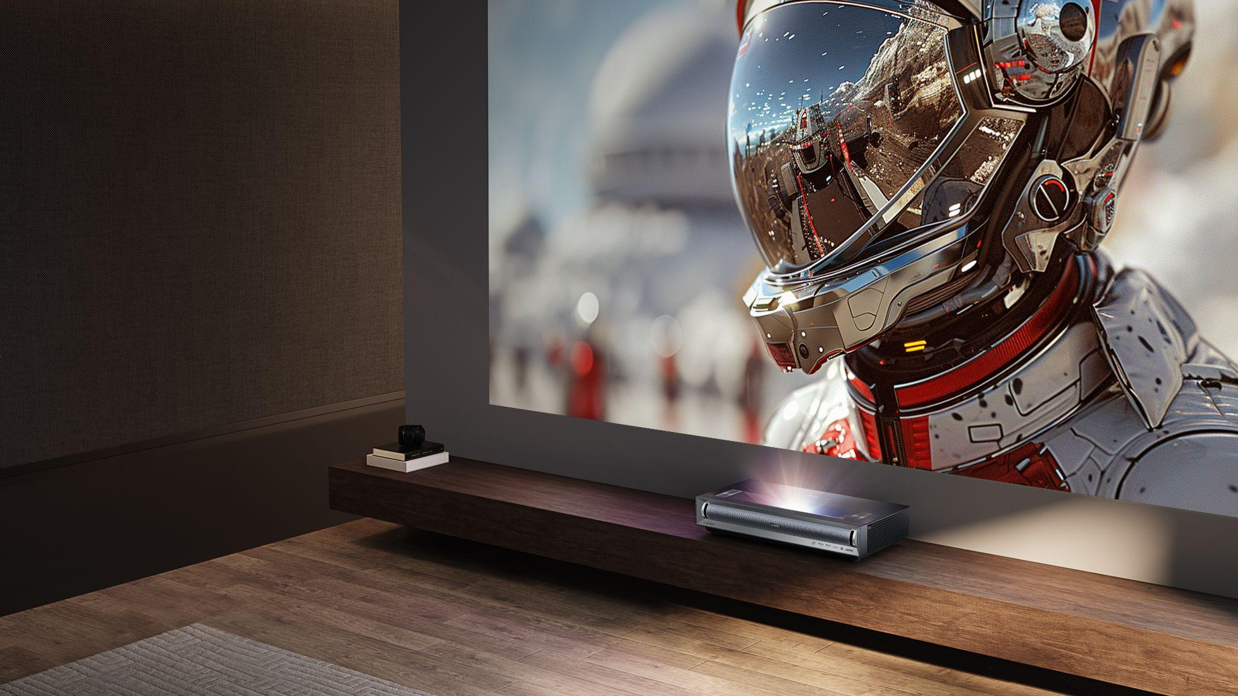

**SUWANEE, GA (April 24, 2024) –** [Hisense](http://www.hisense-usa.com), a global leader in the consumer electronics and home appliance industries, today announces PX3-PRO, the first of its 2024 laser product lineup, ushering in a new era of home cinema. The latest premium ultra short throw projector is a testament to Hisense’s commitment to redefining the high-end entertainment experience, bringing even more options to consumers. Designed for home theater enthusiasts, the PX3-PRO boasts an adjustable 80 to 150-inch screen size and top-notch picture quality thanks to Hisense’s stand-out LPU™ and TriChroma™ triple-laser projection technology.

“We’re all drawn to the magic of big-screen cinema and the immersive experience that pulls you into the story,” said David Gold, President of Hisense Americas and Hisense USA. “The PX3-PRO is our answer to this demand, bringing the essence of cinema into your home with unmatched realism, depth, and immersion. It delivers exceptional picture and sound, along with all the enhancements that make movies truly memorable.”

The PX3-PRO elevates the home theater experience by integrating Hisense’s advanced LPU and TriChroma triple-laser projection technology, setting a new standard for visual excellence, while real-time Pro AI Algorithms enhance brightness, fine-tune contrast, and eliminate noise. This ultra short throw projector delivers vivid, realistic images across an immense projection size, adjustable from 80- to 150-inches. The PX3-PRO reaches 110% of the BT.2020 color space, enabling it to display a spectrum of colors that surpass conventional projectors. With 3,000 ANSI lumens of brightness, Dolby Vision, and a native contrast ratio of 3,000:1, the PX3-PRO delivers depth, subtle nuances, and sharp picture performance even in well-lit rooms.

The PX3-PRO doesn’t stop at stunning visuals; it also brings cinematic sound to the forefront with built-in 50-watt front-firing Harman Kardon speakers. Combined with Dolby Atmos, the premium audio engages viewers in sound as immersive as the on-screen action, making the dialogue, soundtrack, and effect feel closer and more impactful. Its ultra short throw design not only maximizes space in the home, but also offers versatility in a variety of rooms and screen setups, ensuring that every entertainment setup is tailored to the viewer’s exact preferences.

Further elevating the PX3-PRO as an ultimate home entertainment package, it also features Google TV integration, providing seamless access to favorite streaming services like Disney+, Netflix, Hulu, and Amazon Prime with support for IMAX Enhanced, HDR10+, and polarized 3D. With high refresh rates for gaming and sports and an immersive cinematic experience for movie buffs, the PX3-PRO takes home viewing to the next level.

The PX3-PRO will be available in the third quarter at select retailers for $3,499.99 MSRP.

For more information about Hisense, visit [www.Hisense-USA.com](http://www.hisense-usa.com) and follow Hisense on [Facebook](https://www.facebook.com/hisenseusa/), [YouTube](https://www.youtube.com/user/HisenseUSA), [Instagram](https://www.instagram.com/hisense_usa/), and [X](https://twitter.com/hisense_usa).

# # #

**About Hisense USA**

Since 2001, Hisense USA Corporation, a subsidiary of Hisense Group, has been a leading provider of technology products, encompassing a diverse range of offerings such as televisions, Laser TVs and Cinemas, refrigerators, ranges, dishwashers, and an array of air conditioners and dehumidifiers. As the *Official TV and Home Appliance Partner of the NBA*, the company places maximum emphasis on performance, quality, and value, leading to remarkable industry growth and a reputation for producing reliable, award-winning products. In 2023, Hisense maintained its position as the second-largest global TV manufacturer for the second consecutive year, demonstrating the company's commitment to superior product quality and the best customer experience.

**Media Contact**

Hisense USA PR

press.usa@hisense.com

Max Borges Agency for Hisense

HisenseCE@maxborgesagency.com