**Introducing CanvasTV, where art meets entertainment to transform living spaces**

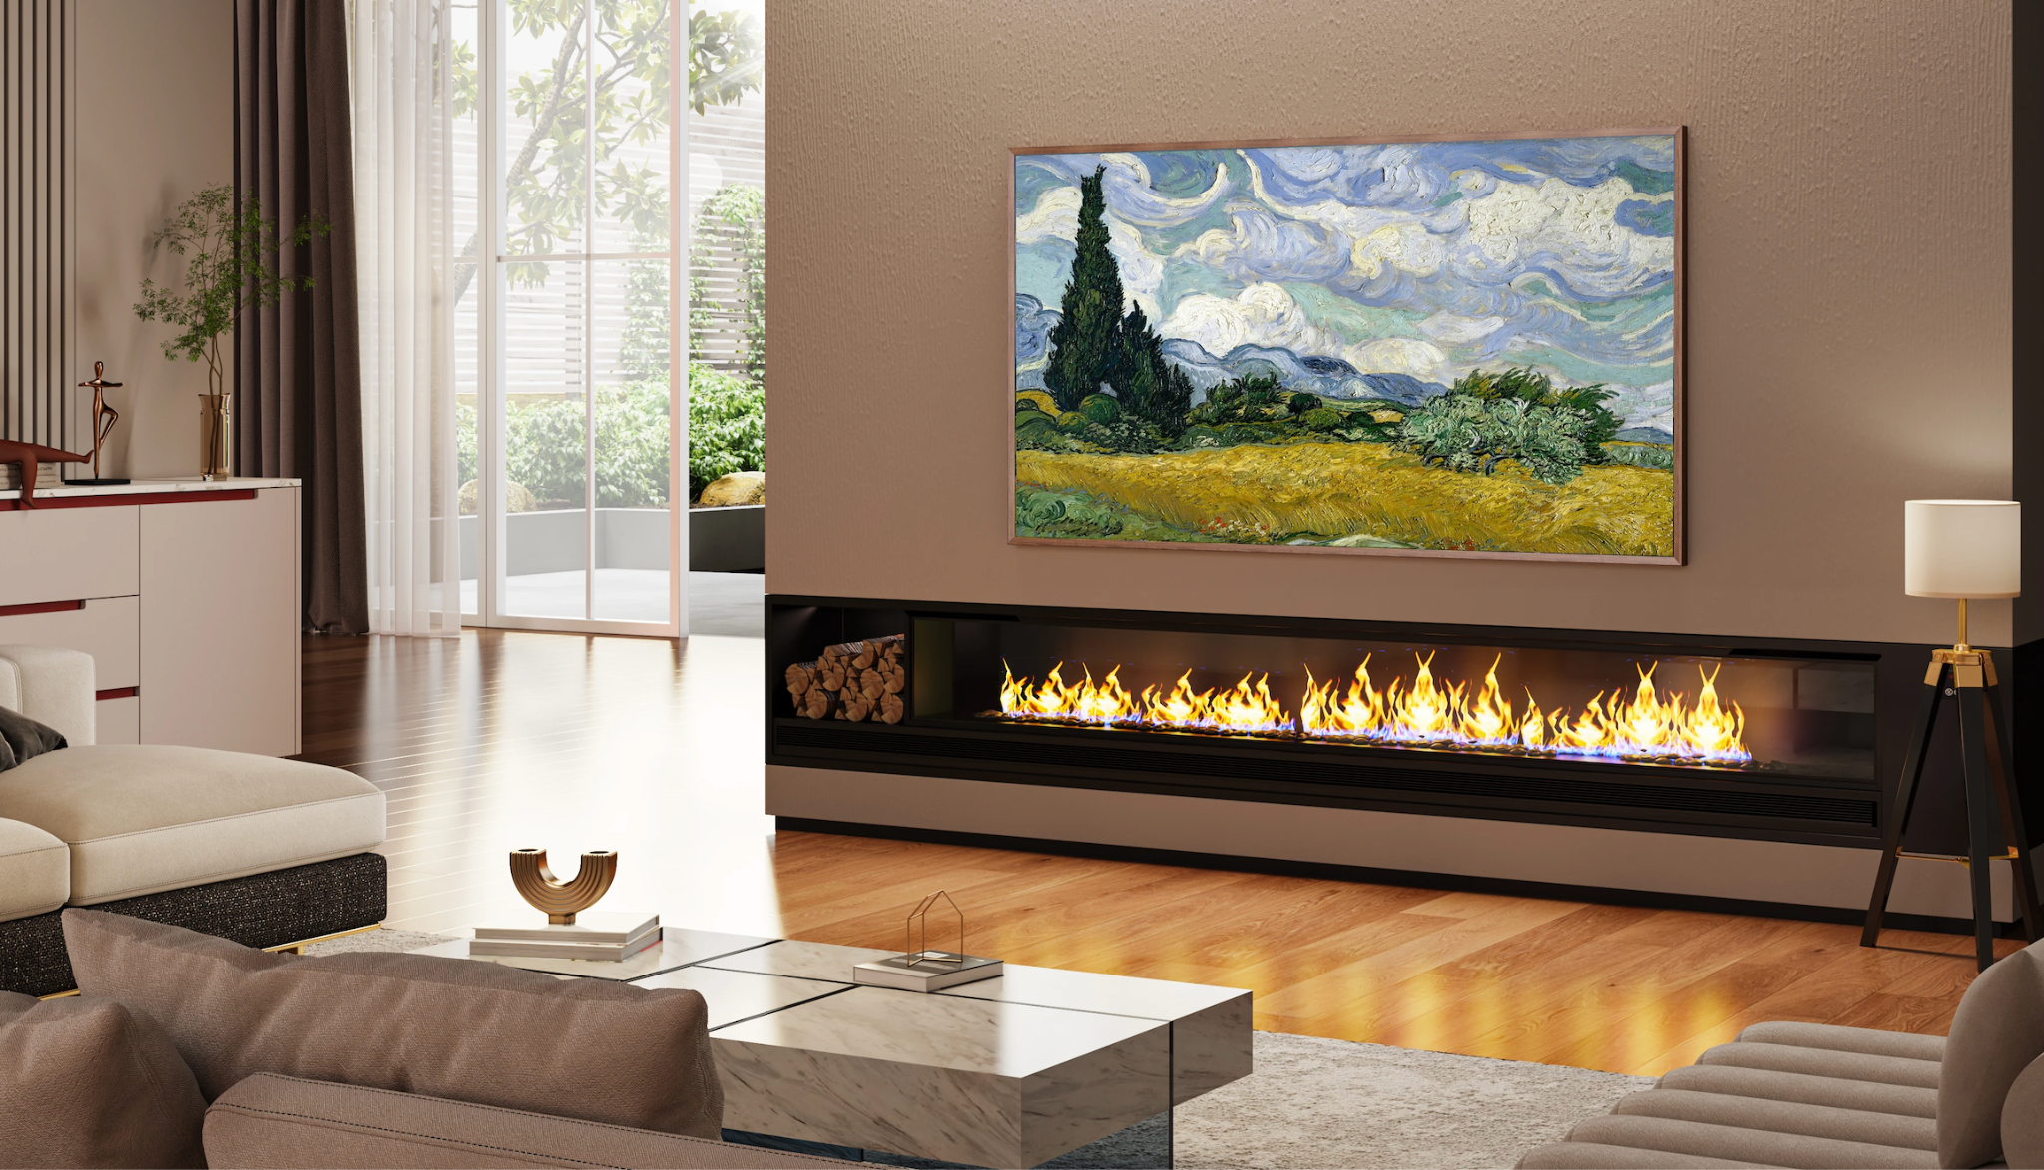

**SUWANEE, GA (APRIL 30, 2024) –** [Hisense](http://www.hisense-usa.com), a global leader in consumer electronics and home appliances, unveils CanvasTV™, redefining the television experience that harmoniously blends art, personalization, and premium picture quality. With interchangeable frames, an Art Mode that curates digital canvases, and Hisense’s premium picture technologies, CanvasTV seamlessly integrates entertainment and art for the modern home. This new offering exemplifies Hisense’s commitment to developing premium products that elevate and complement contemporary lifestyles.

“CanvasTV represents Hisense's philosophy of melding premier home entertainment with modern design sensibilities,” said David Gold, President of Hisense Americas and Hisense USA. “With the ability to transform a living space into an art gallery when not in use, CanvasTV offers the perfect balance of high aesthetics, exceptional technology, and industry-leading picture quality all at Hisense’s best-in-class value.”

**IMMERSIVE ART MODE**

CanvasTV’s Art Mode unlocks a curated world of free artistic masterpieces with a collection of pre-loaded works spanning abstract, modern, and renaissance styles that transform walls into works of art. A simple press of the Art Mode button on the remote gives users the power to seamlessly transition between iconic artworks and personal photographs, which can be customized with rotation preferences and stylized mats. This versatile feature empowers users to curate their own elevated decor, turning CanvasTV into a continuously evolving artistic centerpiece.

Energy efficiency is at the forefront of the CanvasTV’s design with power-saving capabilities in Art Mode that automatically adjusts brightness and utilizes a light sensor to minimize energy consumption. Additionally, its motion sensor detects when viewers are present and automatically turns off the screen when the room is empty, further optimizing energy usage.

**DYNAMIC VISUALS AND SURROUND SOUND**

CanvasTV's 4K QLED with Quantum Dot Color technology delivers over a billion shades of vibrant, lifelike color, for a truly transcendent entertainment experience. The Hi-Matte anti-glare display ensures clarity and vibrancy unaffected by ambient light while mirroring the depth and texture of real paintings for a perfect view day or night. Seamless ambient light adaptation via an RGB sensor further optimizes the viewing environment. Viewers will experience silky-smooth motion, regardless of content, with a 144 Hz refresh rate, courtesy of ALLM, VRR, and MEMC technology. Elevating the immersive experience is CanvasTV’s room-filling, multi-channel 2.0.2 surround sound system that envelopes audiences in rich, resonant audio whether they're watching movies, playing games, or just listening to music.

**SEAMLESS DESIGN PERSONALIZED TO TASTE**

Choose Your Frame, a first in any Hisense TV product, gives CanvasTV owners the option to personalize their TV's appearance. Each CanvasTV comes with a sophisticated teak frame, with optional white and walnut frames available for purchase. The interchangeable frames easily slide onto the TV, held securely in place by embedded magnets, allowing for effortless customization to match any décor.

User-friendly design makes an expertly leveled and flush installation of CanvasTV a breeze. A precision cut-out in the rear housing seamlessly accommodates Hisense’s included UltraSlim Wall Mount, enabling the display to lie virtually flat against the wall for a streamlined, space-efficient look reminiscent of a framed artistic canvas.

**ENTERTAINMENT FOR EVERYONE**

Google TV™ is now available on CanvasTV – bringing together movies, shows, live TV, and more from across apps and subscriptions, so they’re in one place. Get curated recommendations and use Google’s powerful search to find 700,000+ movies and shows across 10,000+ apps or to browse 800+ free live TV channels. Users can simply use their voice to find shows, play music, control smart home devices, and more by pressing the Google Assistant button on the remote. With personalized watchlists and profiles, including dedicated kids profiles, everyone’s experience is customized. Users can also cast movies, shows, photos, and more from their phone or tablet, right to the CanvasTV with Chromecast built-in™. Or just take their favorite entertainment on the go with the Google TV mobile app.

**PRICING AND AVAILABILITY**

CanvasTV by Hisense is set to transform home entertainment, combining stunning design, interchangeable frames, and innovative features to create a truly immersive viewing experience. CanvasTV will be available in 55 and 65-inch screen sizes late summer 2024, starting at $999MSRP.

# # #

Google TV is the name of this device's software experience and a trademark of Google LLC. Google and Chromecast built-in are trademarks of Google LLC.

**About Hisense USA**

Since 2001, Hisense USA Corporation, a subsidiary of Hisense Group, has been a leading provider of technology products, encompassing a diverse range of offerings such as televisions, Laser TVs and Cinemas, refrigerators, ranges, dishwashers, and an array of air conditioners and dehumidifiers. As the Official TV and Home Appliance Partner of the NBA, the company places maximum emphasis on performance, quality, and value, leading to remarkable industry growth and a reputation for producing reliable, award-winning products. In 2023, Hisense maintained its position as the second-largest global TV manufacturer for the second consecutive year, demonstrating the company's commitment to superior product quality and the best customer experience.

**Media Contact**

Hisense USA PR

[press.usa@hisense.com](mailto:press.usa@hisense.com)

Max Borges Agency for Hisense

[hisenseCE@maxborgesagency.com](mailto:hisenseCE@maxborgesagency.com)