**Hisense unveils U9N Mini-LED ULED TV: Gateway to ultra-premium, big-screen entertainment**

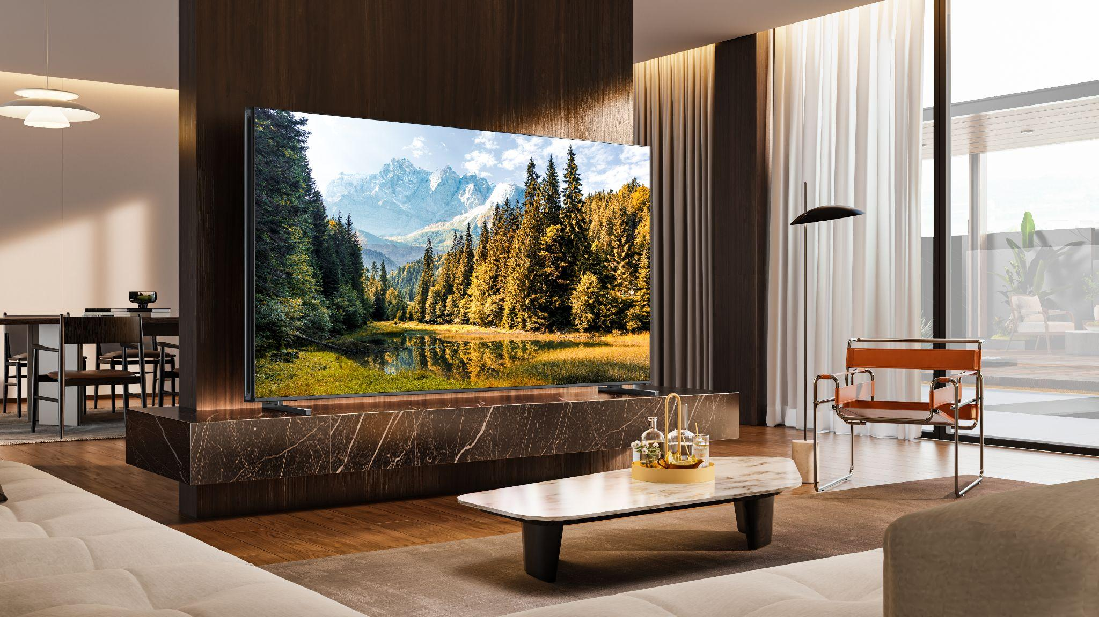

**SUWANEE, GA (April 30, 2024)** **–** [Hisense](http://www.hisense-usa.com), a global leader in consumer electronics and home appliances and official partner of the NBA, proudly introduces the latest addition to its 2024 ULED lineup: the Hisense U9N Mini-LED QLED TV. Sitting at the top of the ULED lineup, U9N delivers an elevated viewing experience for those seeking state-of-the-art innovation and superior viewing quality. Hisense is boldly redefining the premium television landscape, giving consumers more high-end choices and proving that quality experiences can be accessible to a wider audience.

“Our commitment has always been to make premium technology accessible to more people, and with the introduction of the U9N, we're taking this commitment a step further,” said David Gold, President of Hisense Americas and Hisense USA. “The U9N elevates our ULED lineup, bringing elements of ULED X technology to an even wider audience. It's not just a new addition to our growing premium product lineup, it's a testament to our ongoing pursuit of excellence and innovation in home entertainment.”

The U9N is a breakthrough in TV technology that introduces many of the ultra-premium features of Hisense’s ULED X technology to a wider audience, creating a captivating environment for big-screen entertainment. The U9N features Hisense’s cutting edge processing technology, Hi-View Engine X, offering immense control over picture quality and motion accuracy, making everything from the blur of a fast-paced sports game to the subtle hues of a sunset look sharp and fluid.

With the power to fine-tune over a billion colors and illuminate each scene with precise contrast, the U9N delivers increased depth, dimension, and accuracy to all content. Boasting an impressive peak brightness of up to 5,000 nits and equipped with up to 5,300+ dimming zones, the U9N is another example of Hisense’s commitment to innovation, making it the best choice for anyone looking to upgrade to an ultra-premium viewing experience.

QLED Quantum Dot Color technology works seamlessly alongside Mini-LED, Dolby Vision®, and Dolby Vision IQ™ to deliver a superior 4K viewing experience while features such as IMAX Enhanced, Filmmaker Mode, and HDR10+ elevate the U9N Series’ picture quality even further. Running Google TV, the U9N provides fast access to a vast library of over 800 free channels of movies, TV shows, live TV, and more than 10,000 apps – all personalized to individual user preferences and enhanced with hands-free control and far-field voice control.

The U9N Series goes beyond providing a remarkable on-screen viewing experience, offering a comprehensive package for those looking to upgrade their home entertainment. Derived from ULED X technology, CineStage X Surround boasts a 4.1.2 multi-channel audio system, with up to 82W of total power, equipping U9N to deliver a fully immersive audio experience, perfect for enhancing movie nights, big game viewing parties, and more. Coupled with big screen viewing in either 75- or 85-inches and Dynamic X Display with its anti-glare ultra low reflection panel and ultra wide viewing angle, everyone in the room has a front row seat for unparalleled cinematic immersion.

In line with what consumers have come to expect from a high-performing Hisense ULED TV, the U9N incorporates the latest in future-proof technologies such as WiFi 6E, NEXTGEN TV (ATSC 3.0), as well as gaming enhancements such as 144Hz native refresh rate, AMD FreeSync Premium Pro, Auto Game Mode, Dolby Vision Gaming, Game Mode Pro, and Hisense’s new Game Bar feature, which lets users customize their gameplay screens, bringing the action to life. Regardless of the content, the U9N is equipped to consistently deliver an outstanding performance, setting a new standard in home entertainment.

The U9N Series will be available on BestBuy.com in Summer 2024 for $2,999 MSRP in the 75-inch size and $3,999 MSRP in the 85-inch size.

For more information about the U9N visit [www.hisense-usa.com](http://www.hisense-usa.com), and follow @HisenseUSA on [Facebook](https://www.facebook.com/hisenseusa/) and [YouTube](https://www.youtube.com/user/HisenseUSA) and @Hisense_USA on [Instagram](https://www.instagram.com/hisense_usa/) and [X](https://twitter.com/hisense_usa).

# # #

**About Hisense USA**

Since 2001, Hisense USA Corporation, a subsidiary of Hisense Group, has been a leading provider of technology products, encompassing a diverse range of offerings such as televisions, Laser TVs and Cinemas, refrigerators, ranges, dishwashers, and an array of air conditioners and dehumidifiers. As the Official TV and Home Appliance Partner of the NBA, the company places maximum emphasis on performance, quality, and value, leading to remarkable industry growth and a reputation for producing reliable, award-winning products. In 2023, Hisense maintained its position as the second-largest global TV manufacturer for the second consecutive year, demonstrating the company's commitment to superior product quality and the best customer experience.

**Media Contact**

Hisense USA PR

press.usa@hisense.com

Max Borges Agency for Hisense

HisenseCE@maxborgesagency.com