**Memorial Day savings on Hisense’s award-winning 2024 ULED Mini-LED 4K QLED Google TV**™ **lineup**

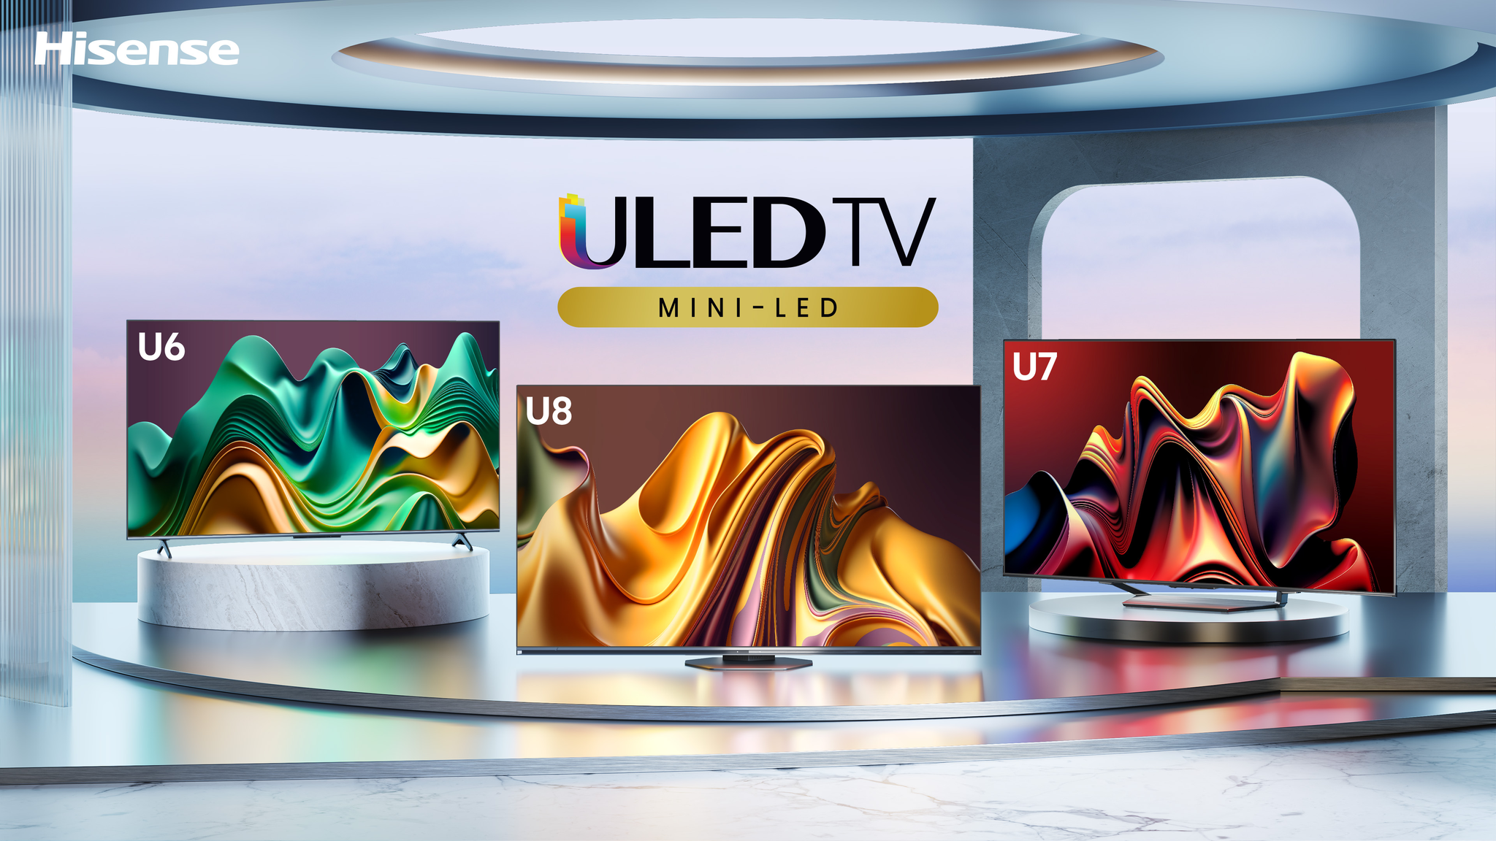

**SUWANEE, GA (May 20, 2024)** **–** [Hisense](http://www.hisense-usa.com), a global leader in consumer electronics and home appliances and official partner of the NBA, kicks off Memorial Day deals on their highly-anticipated U6N, U7N and U8N Mini-LED QLED 4K Google TVs, available now for purchase. Building on the success of Hisense's award-winning 2023 lineup, the 2024 televisions soar to new heights, offering cutting-edge technology and hitting shelves at an unmatched price point starting at $449.99, $150 off MSRP ($599.99). Additionally, from now through June 15, customers will receive [a free $50–$200 NBA Store e-gift card](https://enter.giveaways.joinsurf.com/hisense-forthewin) with select Hisense TVs – including the new ULED lineup.

Get ready to experience entertainment on a whole new level with Hisense's 2024 ULED lineup. Mini-LED and QLED-Quantum Dot technology come alive with stunning colors and deep blacks, further enhanced by IMAX Enhanced, Filmmaker Mode, and Dolby Vision for breathtaking HDR. And with the new Game Bar, lightning-fast 144Hz refresh rate, and advanced features like AMD FreeSync Premium Pro, viewers will enjoy an ultra-smooth, tear-free experience. Witness brighter scenes with up to 3,000 nits of peak brightness and experience unparalleled contrast with thousands of dimming zones. Streamers, sports fanatics, and movie buffs can all enjoy seamless content viewing with the 2024 ULED lineup featuring NEXTGEN TV, WiFi 6E, and Google TV. And with expansive 100-inch displays to budget-friendly options starting under $500, Hisense delivers exceptional value no matter the screen size. This is performance, quality, and value redefined.

**Hisense U8N: Best Premium Value of 2024**

* **Premium Quality:** Featuring Mini-LED, QLED Quantum Dot Color, up to 3000+ nits of peak brightness, and up to double the number of local dimming zones – now exceeding 2,000 zones – the U8N delivers vibrant colors, improved contrast, and lifelike visuals for a well-rounded viewing experience.
* **AI-Powered Picture:** The new Hi-View Engine Pro chipset leverages advanced AI to deliver an even more optimized, lifelike, and detailed images on the screen.
* **Enhanced Audio:** Enjoy a major audio enhancement with a 2.1.2 channel sound system delivering up to 60 watts of power, ensuring a well-rounded entertainment experience. Combined with Dolby Atmos®, the U8N creates a multi-dimensional soundstage that immerses the viewer in every moment.
* **Future-Proof Reliability:** The U8N Series is equipped with future-proofing features to ensure years of enjoyment. Benefit from NEXTGEN TV (ATSC 3.0) for free, live over-the-air broadcast content in 4K HDR and Dolby audio, 144Hz native refresh rate for smooth gaming and action, and WiFi 6E for uninterrupted streaming.
* **Expansive Viewing:** With screen sizes ranging from 55- to 85-inches, the U8N Series caters to every home and viewing preference, ensuring everyone can enjoy unmatched clarity and scale.

The U8N Mini-LED QLED 4K Google TV is now available starting at **$799.99** ~~($1,099.99 MSRP)~~ at [Walmart](https://www.walmart.com/ip/Hisense-55-Inch-Class-U8-Series-Mini-LED-Pro-ULED-4K-UHD-Google-Smart-TV-55U8N-QLED-Quantum-Dot-Color-Dolby-Vision-Native-144Hz-Full-Array-Local-Dimm/5373792347), [Best Buy](https://www.bestbuy.com/site/hisense-55-class-u8-series-mini-led-4k-qled-google-tv/6577013.p?skuId=6577013), [Amazon](https://www.amazon.com/Hisense-55-Inch-Mini-LED-Google-55U8N/dp/B0CY4TQ91Q/ref=sr_1_3?crid=1TOLBPELZZQ3D&dib=eyJ2IjoiMSJ9.RXOyp4RfAK_0sc_QOqBHWd5lcLX6CELgJ8rw7jIErggTE-6yanx1IUJyMZCW3HKxznu6j-VXIlxAvn3kdrvy_I3z6eN3pO5Wir2Y2ZBLVekp-s9ow8iyIKwnRzQehGgYtoh4aFKzKVZlnOGnC4WEITsBnL3MSWCxgeTiKCkZH8N74b39PPl1Y7Sxn5mOjJ3pE4beP0YbLwB6FwlGSeVcfcAR7hwtIrUyzJyl8fD0Mos.cF-b9El470Dim4y3OOZ99shxhZNxBuREv6u4ei_iC54&dib_tag=se&keywords=hisense+55u8n&qid=1715897541&sprefix=hisense+55u8n%2Caps%2C84&sr=8-3), and all authorized Hisense retailers.

**Hisense U7N: A Game-Changer**

* **Best 65-inch TV Under $1,000:** The U7 Series packs a punch with features that outshine other Mini-LED QLED TVs. With its fusion of Mini-LED technology and QLED Quantum Dot color accuracy, plus future-ready enhancements such as WiFi 6E and NextGEN TV, the U7N ushers in a new era of premium television. Delivering a lifelike picture, the U7N redefines expectations in the premium TV landscape, priced at just $799.99.
* **Elevated Performance:** The U7N series brings together Mini-LED technology, Quantum Dot color precision, IMAX Enhanced visuals, NextGEN TV capabilities, Filmmaker Mode, and WiFi 6E, complemented by up to 700+ full array local dimming zones for unparalleled brightness, vibrant colors, and superior contrast.
* **Next-Level Gaming:** Boasting a native 144Hz refresh rate, Auto Low Latency Mode (ALLM), and Game Mode Pro complemented by Hisense’s new Game Bar, the U7N allows for seamless customization and adjustment of gameplay settings. With Game Enhancement technology, experience Variable Refresh Rate (VRR) gaming and AMD FreeSync Premium Pro for the ultimate in fluid motion and tear-free action.

The U7N Mini-LED QLED 4K Google TV is now available starting at **$599.99** ~~($799.99 MSRP)~~ via [Best Buy](https://www.bestbuy.com/site/hisense-55-class-u7-series-mini-led-4k-qled-google-tv/6577007.p?skuId=6577007&utm_source=feed&ref=212&loc=TVsGeneral&gad_source=1&gclid=CjwKCAjw88yxBhBWEiwA7cm6paSkUbGnsjWN7Vxwjd-clB934RzgJUZmRZ4ksF1jyUsO3DXybpAP-xoCGjoQAvD_BwE&gclsrc=aw.ds), [Walmart](https://www.walmart.com/ip/Hisense-55-Inch-Class-U7-Series-Mini-LED-Pro-ULED-4K-UHD-Google-Smart-TV-55U7N-QLED-Quantum-Dot-Color-Dolby-Vision-Native-144Hz-Up-1500-Nit-Full-Arra/5478609448), [Amazon](https://www.amazon.com/Hisense-55-Inch-Mini-LED-Google-55U7N/dp/B0CY56XCJ9/ref=sr_1_3?crid=D7S0AEVSIHCI&dib=eyJ2IjoiMSJ9.GOba9q5schKaLIzR2_F-akp9UHP3uN0fa6KajDUpo8f2WlI5KTHqyA6y4aGq9owSaFNgF8aXB1SIcJJydp3DiuVSVixqtjRBnguPiKZjZBQKygQFbjgamKh-kOWKUFJ5Cv1T9k1CLeTDwzmzTW_fuuQIJ2L10fKe_kt7Q0lLOnGnCXp2x3O50wnVQFTmhYIPvNCV59fU3l_zUNnVRYsLXAeYlA4UhetIIftYWHtTJHU.sYrZGXzm_P4zcWhBbJfqhjbojWcWzWYcLLMeFWjP53E&dib_tag=se&keywords=hisense+55u7n&qid=1715897634&sprefix=hisense+55u7n%2Caps%2C106&sr=8-3), and all authorized Hisense retailers.

**Hisense U6N: Best Entry Into Premium TV**

* **Premium Performance Within Reach:** Elevate any viewing experience with the U6N, bringing unparalleled quality, performance, and value to a wider audience. The U6 Series boasts Mini-LED QLED and full array local dimming zones for more realistic images and superior contrast. As the leading TV series on the market offering an accessible entry point to premium, Mini-LED technology, the U6N maintains its status as the best value in premium television and sets a new expectation for affordability and high-end features.
* **Making Mini-LED QLED Mainstream:** U6N showcases the remarkable benefits of Mini-LED QLED technology, offering consumers a brighter, more realistic picture, enhanced contrast, with even more clarity and uniformity. Hisense stands out in its commitment to integrating Mini-LED QLED technology across the full spectrum of its premium offerings, starting with the U6 Series. By providing an accessible gateway to top-tier performance, Hisense continues to lead the charge in making Mini-LED the standard in mainstream televisions.
* **Best Entry to Premium TV:** The U6 Series redefines the entry point for premium televisions, combining essential features with unmatched performance and value. With screen sizes ranging from 55-inches to the new 85-inch, the U6 features Mini-LED, QLED Quantum Dot Color, Dolby Vision and Dolby Atmos, Google TV, and more – all at an unbeatable starting price.

The U6N Mini-LED QLED 4K Google TV is now available starting at **$449.99** ~~($599.99 MSRP)~~ at [Amazon](https://www.amazon.com/Hisense-55-Inch-Mini-LED-Google-55U6N/dp/B0CY4X5M8D/ref=sr_1_1?crid=2X45J3NA95BEE&dib=eyJ2IjoiMSJ9.vWTtxRtQhQGOLguY-pU2RsEN7nEz4bk1PycdA3nQD_XdkboDL3VGOtQM72U2dYdckwg2n6SKBSC3OyDnEDegA5EPEXDFmFJdLz2un-1yW6E56Emon_yzauI6WcPmMcfdlLckuWlVz_1_S52aOhFdgIXR3UouSb8SgR2uSwumqpODqAjiwc9Uc8_f4fH8UXHWRpCx5ZLLk0rcJ3JULk3o3ij-5w5UNjI-LLagizXliT8.XwoVWfnqU9_1MsDHuiq3NbXG1PokLQZJIMFWoD5n35o&dib_tag=se&keywords=hisense%2B55u6n&qid=1715897672&sprefix=hisense%2B55u6n%2Caps%2C81&sr=8-1&th=1), [Best Buy](https://www.bestbuy.com/site/hisense-55-class-u6-series-mini-led-4k-qled-google-tv/6577009.p?skuId=6577009), [Walmart](https://www.walmart.com/ip/Hisense-55-Inch-Class-U6-Series-Mini-LED-ULED-4K-UHD-Google-Smart-TV-55U6N-QLED-Quantum-Dot-Color-Dolby-Vision-Full-Array-Local-Dimming-Game-Mode-Plu/5478609239?adsRedirect=true), and all authorized Hisense retailers.

For more information about Hisense’s latest ULED lineup, visit [www.hisense-usa.com](http://www.hisense-usa.com), and follow @HisenseUSA on [Facebook](https://www.facebook.com/hisenseusa/) and [YouTube](https://www.youtube.com/user/HisenseUSA) and @Hisense_USA on [Instagram](https://www.instagram.com/hisense_usa/) and [X](https://twitter.com/hisense_usa).

# # #

**About Hisense USA**

Since 2001, Hisense USA Corporation, a subsidiary of Hisense Group, has been a leading provider of technology products, encompassing a diverse range of offerings such as televisions, Laser TVs and Cinemas, refrigerators, ranges, dishwashers, and an array of air conditioners and dehumidifiers. As the Official TV and Home Appliance Partner of the NBA, the company places maximum emphasis on performance, quality, and value, leading to remarkable industry growth and a reputation for producing reliable, award-winning products. In 2023, Hisense maintained its position as the second-largest global TV manufacturer for the second consecutive year, demonstrating the company's commitment to superior product quality and the best customer experience.

**Media Contact**

Hisense USA PR

press.usa@hisense.com

Max Borges Agency for Hisense

HisenseCE@maxborgesagency.com