Hisense and Fire TV Bring Exceptional QLED TV Experience to Costco

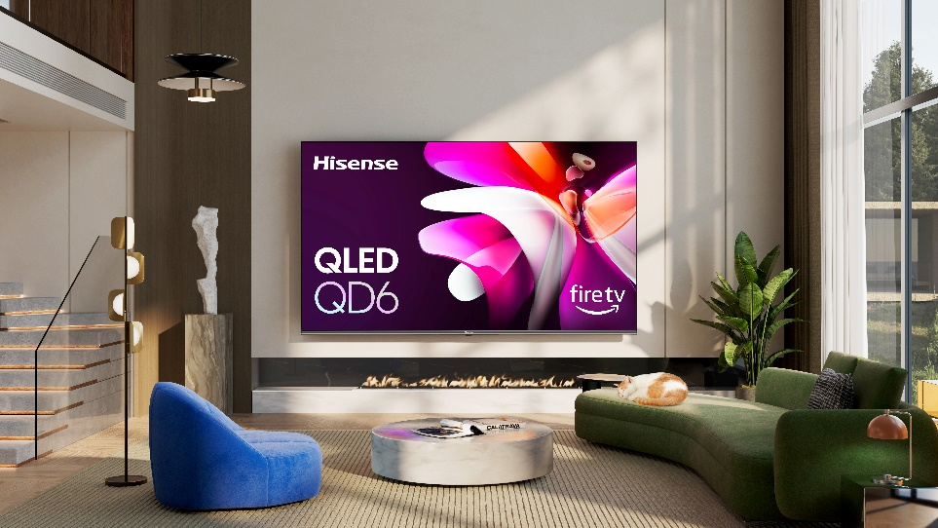

SUWANEE, GA (May 28, 2024) – Hisense, a global leader in consumer electronics and home appliances, has announced the latest addition to the lineup of smart TVs with Fire TV built in, the QD65NF QLED Series. Now available at Costco locations nationwide, the newest Hisense smart TV with Fire TV built in seamlessly blends the company’s premium display technology with Fire TV’s content-forward OS, delivering customers an innovative viewing experience.

Featuring screen sizes ranging from 43 to 75 inches, the QD65NF Series with Fire TV built in gives customers access to over 1.5 million movies and TV episodes from popular steaming apps, all of which can be accessed with Alexa Voice Remote. Additionally, the QD65NF doubles as a smart home hub that can control lighting, thermostat control, and more – consolidating multiple functionalities into one sleek device.

“We are thrilled to partner with Amazon Fire TV and introduce this exceptional QLED model to Costco,” said David Gold, President of Hisense Americas and Hisense USA. “The QD65NF exemplifies Hisense’s commitment to delivering high-quality products with outstanding performance and premium technology, all while providing unparalleled value to our consumers.”

The QD65NF boasts Hisense’s QLED Quantum Dot Color technology, dramatically increasing the color space and enhancing overall color saturation for a cinema-quality experience in the comfort of your home. Furthermore, the television features Dolby Vision HDR and Dolby Atmos audio technology, ensuring an immersive audio-visual experience that captures every detail.

"We're excited to expand our collaboration with Hisense and bring more premium viewing options to customers in the U.S. with the launch of the QD65NF QLED TVs," said Daniel Rausch, Vice President of Alexa and Fire TV. "These smart TVs combine Hisense's exceptional display technology with the intuitive and personalized streaming experience of Fire TV. Customers can easily discover their favorite content and control their smart home using just their voice with Alexa - delivering a truly elevated entertainment experience."

The 43-inch, 50-inch, 55-inch, and 65-inch QD65NF models are now available at Costco.com and in-store nationwide, starting at an MSRP of $199.99. The 75-inch QD65NF will be available at Costco.com from June 10, priced at an MSRP of $579.99. All sizes of the QD65NF will come with a three-year warranty, an exclusive Costco member value.

For more information about the new Hisense QD65NF, visit www.hisense-usa.com and www.costco.com, follow @HisenseUSA on Facebook and YouTube and @Hisense_USA on Instagram and X.

# # #

About Hisense USA

Since 2001, Hisense USA Corporation, a subsidiary of Hisense Group, has been a leading provider of technology products, encompassing a diverse range of offerings such as televisions, Laser TVs and Cinemas, refrigerators, ranges, dishwashers, and an array of air conditioners and dehumidifiers. As the Official TV and Home Appliance Partner of the NBA, the company places maximum emphasis on performance, quality, and value, leading to remarkable industry growth and a reputation for producing reliable, award-winning products. In 2023, Hisense maintained its position as the second-largest global TV manufacturer for the second consecutive year, demonstrating the company's commitment to superior product quality and the best customer experience.

Media Contact

Hisense USA PR
press.usa@hisense.com

Max Borges Agency for Hisense
HisenseCE@maxborgesagency.com

