**Hisense Secures No. 2 Spot in Global TV**

**Shipments Share for Third Consecutive Year**

**Suwanee, GA (Feb. 3, 2025)** – [Hisense](https://www.hisense-usa.com/televisions/hisense-100-qd7-series-qled-google-tv-100qd7n-hisense), a leading brand in global consumer electronics and home appliances, has reinforced its dominance in the global TV market achieving an unprecedented three consecutive years of second-highest annual TV shipment volume worldwide. According to the latest report from AVC Revo, Hisense demonstrated exceptional performance in 2024, capturing a significant year-on-year shipment increase of 11.9%. From 2022 to 2024, Hisense TVs have consistently maintained No. 2 spot in global TV shipments share for three consecutive years.

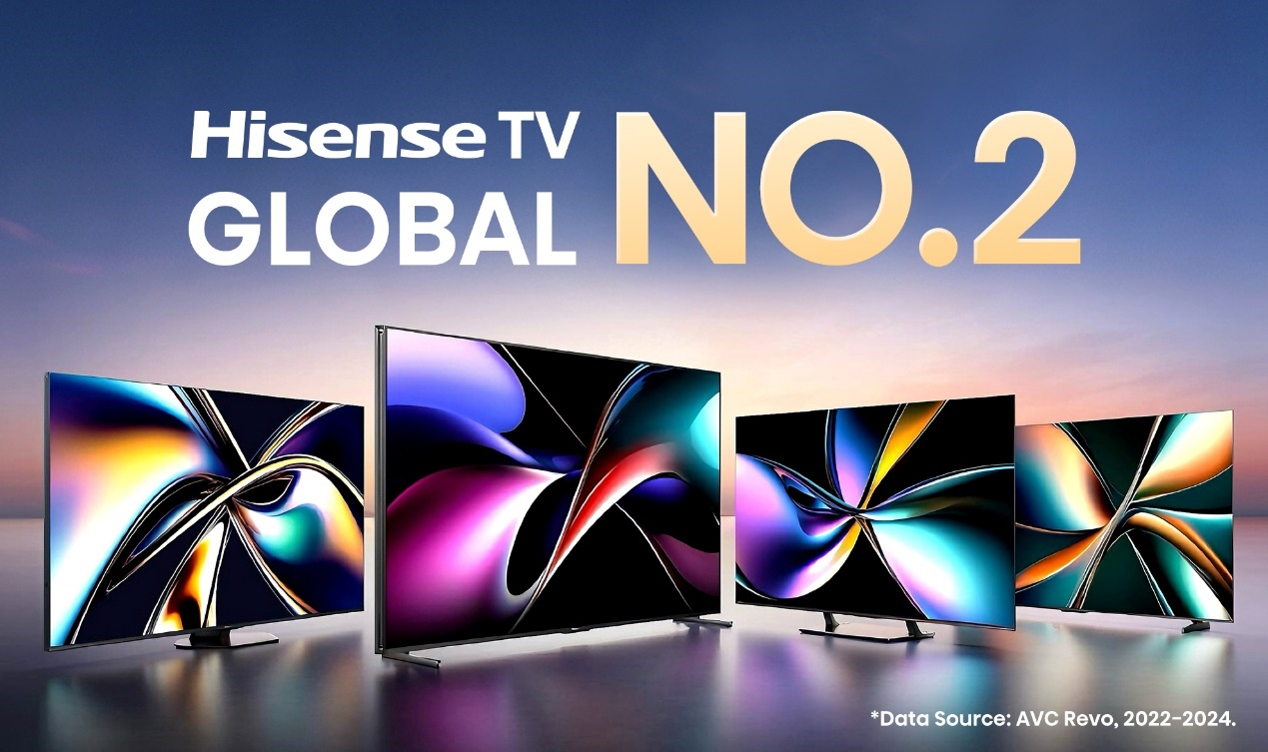

In 2024, Hisense consolidated its position in the worldwide TV market, accounting for 14% share of global TV shipments. Benefiting from sponsoring major sporting events and the strong market demand for large screen TV, Hisense achieved a shipment share of 47% in the global 100-inch-and-above TV market in 2024, ranking No.1 worldwide.

Driving this success is Hisense's relentless pursuit of technological advancements. At CES 2025, the company unveiled groundbreaking innovations, including the revolutionary 116-inch TriChroma LED TV with RGB Local Dimming Display Technology and the consumer-ready 136-inch MicroLED display, showcasing a bold vision for the future of home entertainment. Hisense is also elevating the TV viewing experience to new heights of personalization and convenience. These innovations will provide fans with immersive experience in the FIFA Club World Cup 2025™.

“For me, the three keywords for 2024 were passion, dedication, and innovation.” said David Gold, Vice President of Hisense International and President of Hisense Americas. “With these three key words, it's how we were able to really achieve such strong results throughout the year.”

From driving the innovation of ultra-high definition, intelligent displays to creating seamless AI technology that works behind the scenes; from advancing energy-efficient solutions to driving immersive entertainment experiences, Hisense is committed to technology that is rooted in delivering real value to consumers and improving how people live, connect, and enjoy the moments that matter most.

**About Hisense**

Hisense is a leading global home appliance and consumer electronics brand. According to Omdia, Hisense ranked No. 2 globally for total TV shipments and No. 1 in 100-inch+ TVs. The company has rapidly expanded to operate in more than 160 countries and specializes in multi-media goods, home appliances, and intelligent IT information.