FOR IMMEDIATE RELEASE

HISENSE COMFORT UNVEILS NEXT-GENERATION HVAC SOLUTIONS AT AHR EXPO 2025

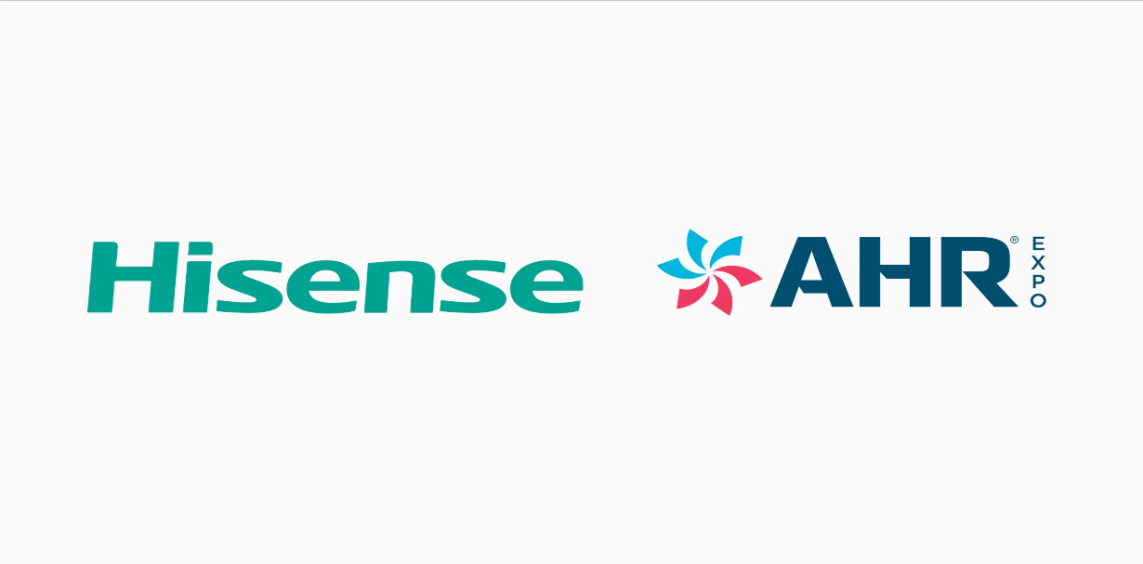

Experience Hisense Comfort’s Latest Innovations in Orlando, February 10-12 at Booth #6891, Orange County Convention Center

ORLANDO, FL (Feb. 10, 2025) – Hisense Comfort, a global leader in heating, ventilation, and air conditioning (HVAC), is unveiling its latest advancements at AHR Expo 2025 in Orlando, Florida. Strengthening its commitment to the North American market, Hisense Comfort is introducing a cutting-edge lineup of energy-efficient climate solutions designed to meet the evolving demands of both residential and commercial customers.

RESIDENTIAL SOLUTIONS: THE FUTURE OF HOME CLIMATE CONTROL
Hisense Comfort offers an expanded range of advanced residential climate solutions, delivering enhanced energy efficiency, seamless adaptability, and superior performance. Designed for modern homes, these solutions provide intelligent comfort, optimized power savings, and flexible installation options for both new construction and retrofit applications.

HD Series – Universal Ducted Solutions

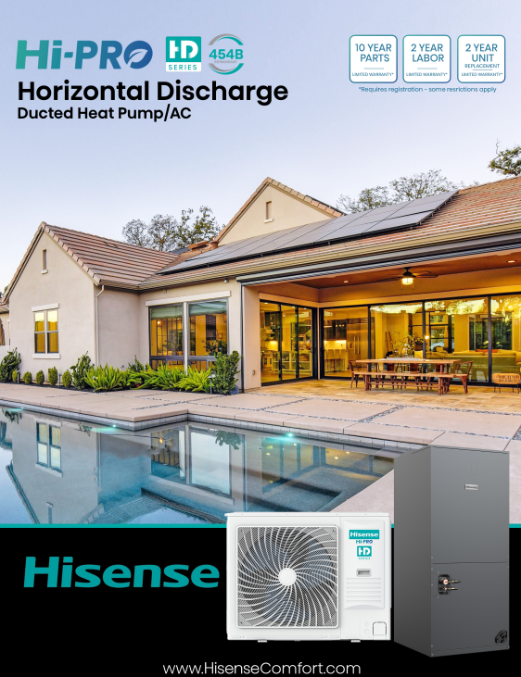
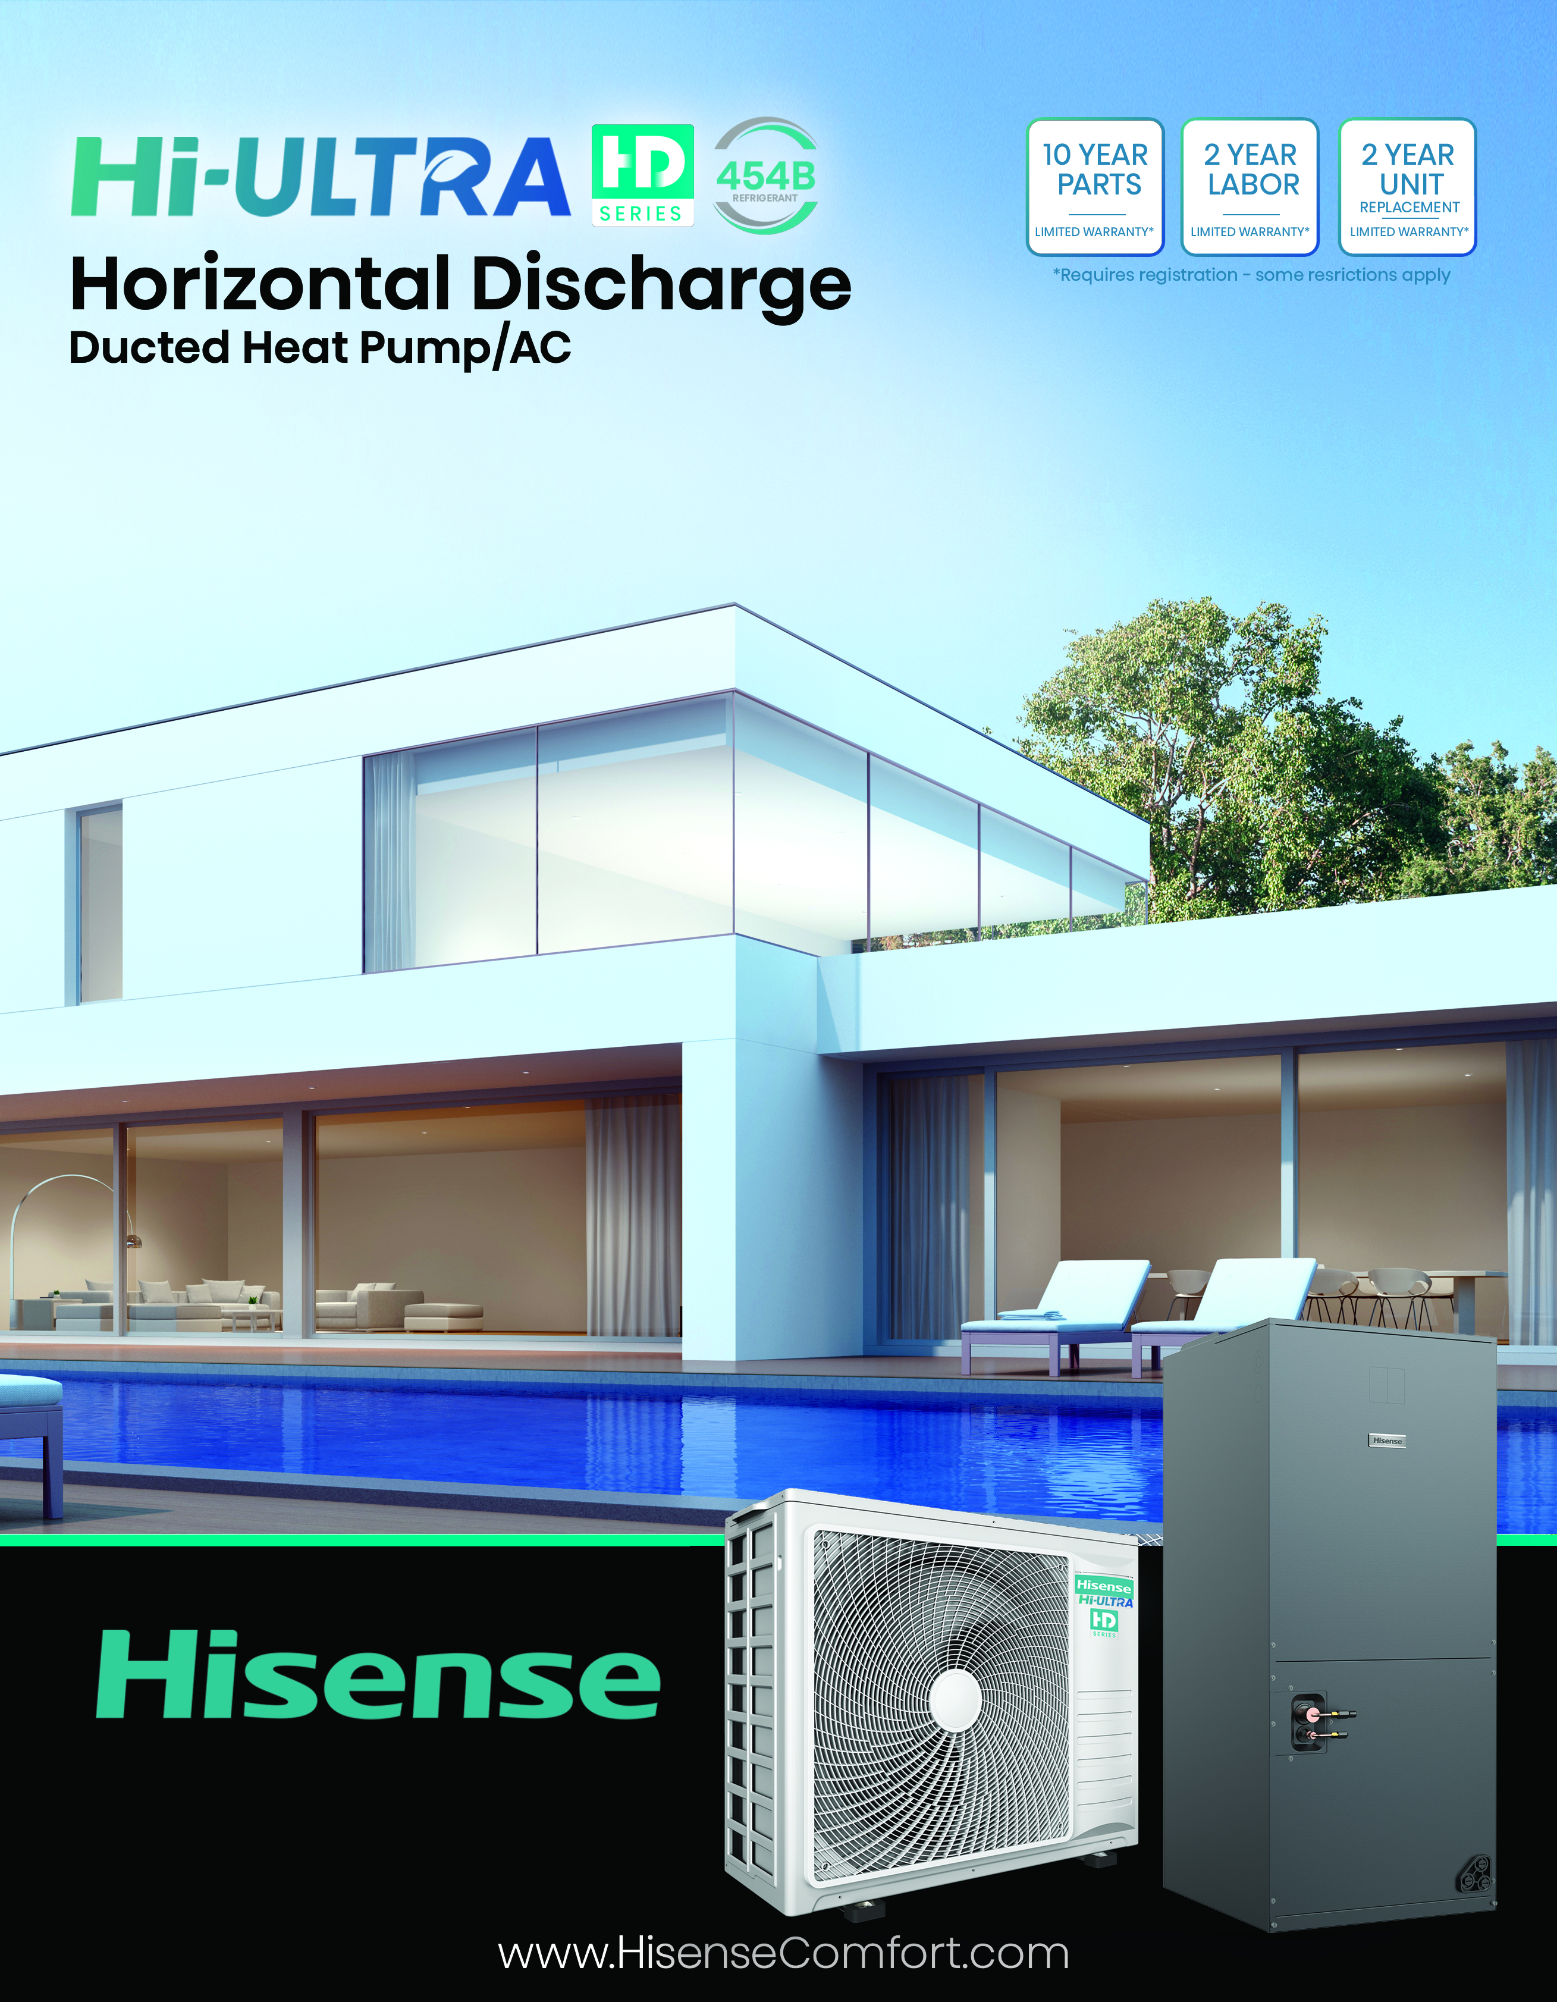

The Hisense HD Series offers high-efficiency, flexible ducted solutions for residential and light commercial applications. Its compact, slim side-discharge design allows for wall mounting or elevation, ensuring clearance from snow and flooding. Engineered for universal compatibility, it supports AHU, coil-only + furnace, and third-party coils, making it ideal for new installations and retrofits. With existing line set compatibility and 24V thermostat connections—installation is seamless. Models include Hi-PRO HD (up to 20 SEER2, -13°F heating, 125°F cooling with 100% at 110°F), Hi-ULTRA HD (18 SEER2, -10°F heating, 115°F cooling), and Hi-EDGE HD R32 (16 SEER2, -4°F heating), all featuring a built-in condenser base pan heater, crankcase heater, refrigerant leak alarms, and quiet 54dB operation. With air handler capability up to 0.8” WC ESP, these systems provide optimal airflow and reliable year-round comfort.

Ductless Single Zone – Hi-PRO, Hi-ULTRA, Hi-EDGE
The Hisense Hi-PRO, Hi-ULTRA, and Hi-EDGE ductless single-zone systems deliver high-efficiency heating and cooling with SEER2 ratings up to 32. Hi-PRO heats down to -22°F (-30°C) with 100% capacity at 5°F (-15°C), Hi-ULTRA maintains 90% capacity at 5°F (-15°C) and operates at -13°F (-25°C), while Hi-EDGE (R32 refrigerant) heats to -4°F (-20°C). All models offer 100% cooling at 104°F (40°C), Hisense FrostClean™ self-cleaning technology, whisper-quiet operation, and smart connectivity, WiFi capability standard, combining performance, efficiency, and sleek design for year-round comfort.

Ductless Multi-Zone/Universal – Hi-MULTI & Hi-UNI
The Hisense Hi-MULTI and Hi-UNI ductless systems provide customizable, high-efficiency climate control, with SEER2 ratings up to 23 and HSPF2 up to 10. Hi-MULTI supports up to five indoor units with flexible installation options, while Hi-UNI, a universal outdoor unit, integrates with multiple indoor unit types. With extended pipe lengths and significant height differentials, both models suit multi-level layouts. They operate in extreme temperatures, offering cooling from 5°F to 125°F (-15°C to 52°C) and heating down to -13°F (-25°C), ensuring efficient, year-round comfort for new construction and retrofits.

Hi-PAK 2-5 Ton Inverter Packaged Units
Engineered for high-performance efficiency, the Hi-PAK series delivers up to 18 SEER2 efficiency and utilizes R-32 refrigerant for sustainable climate control. The Hi-PAK system is designed to perform in extreme cold climates, maintaining over 70% heating capacity at 5°F and operating effectively in temperatures as low as -13°F. Hi-PAK units offer flexible capacity with combined 2-3 ton and 4-5 ton options for reduced SKUs.

Hi-WATER Heat Pump Water Heater
The Hi-WATER Heat Pump Water Heater offers a sustainable approach to water heating, available in 53- and 66-gallon tank options. This system can heat water up to 167°F (75°C) while utilizing R290a refrigerant for enhanced efficiency and environmental benefits. Featuring Hisense ConnectLife smart settings and monitoring, the system allows for seamless remote control and optimization.

COMMERCIAL INNOVATIONS: REDEFINING BUSINESS EFFICIENCY
Hisense Comfort offers commercial climate solutions designed to enhance operational efficiency and sustainability.

Hi-COMFORT Air + Water

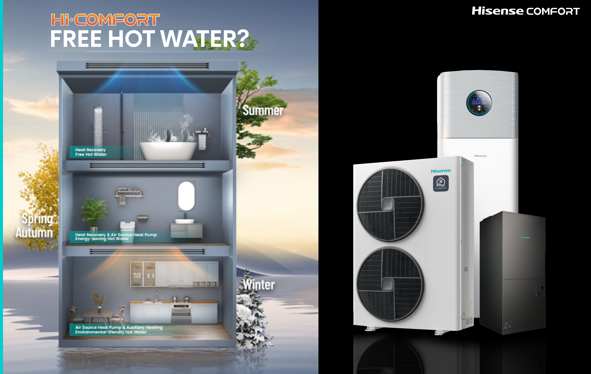

The Hi-COMFORT Air + Water system combines air conditioning and domestic hot water using advanced heat recovery technology, all from one outdoor unit. Designed for 3-5T single-phase VRF, it features a 60-gallon enamel-coated water tank and maintains full capacity down to 5°F for heating and cooling. Supporting up to 13 indoor units, it seamlessly integrates into HVAC and plumbing systems, maximizing efficiency and cost savings for residential and commercial applications.

VRF Split Rooftop Systems
Hisense VRF Split Rooftop systems deliver high-efficiency climate control with top-discharge extreme low ambient operation and side-discharge options in 6-12 tons. Designed for commercial flexibility, these systems include heat recovery, DOAS, and ERV capabilities, ensuring precise temperature control and reduced energy consumption. The split rooftop design allows seamless integration with VRF rooftop air handlers or traditional VRF indoor heads, making it a reliable and cost-effective solution for large-scale applications.

Hisense Comfort – A Trusted Name in Climate Solutions
With extensive expertise in the industry and a track record of manufacturing over 20 million inverter HVAC systems annually, Hisense Comfort continues to set the standard for performance, quality, and value. Customers benefit from an industry-leading 10-year parts warranty, up to 2-year labor warranty, and up to 2-year unit replacement warranty on most systems, ensuring long-term dependability and peace of mind.

As a globally recognized brand, Hisense has solidified its leadership in consumer electronics, achieving three consecutive years of the second-highest annual TV shipment volume worldwide. This legacy of innovation and market dominance extends to Hisense Comfort’s commitment to working exclusively with top-tier national and regional distributors, ensuring exceptional customer service and technical support. Hisense also offers comprehensive distributor incentives, including sales support, contractor programs, and flexible shipping solutions, reinforcing its commitment to long-term partnerships. Additionally, Hisense has formed high-profile partnerships with the NBA, FIFA, and the Golden State Warriors, further strengthening its global influence.

Join Us at AHR Expo 2025
Experience the future of HVAC technology with Hisense Comfort at Booth #6891 in the West Building of the Orange County Convention Center, Orlando, from February 10-12, 2025. Discover first-hand how Hisense is redefining climate control with cutting-edge innovation, superior energy efficiency, and unmatched customer support.

For more information, visit www.hisensecomfort.com.

# # #

About Hisense USA

Since 2001, Hisense USA Corporation, a subsidiary of Hisense Group, has been a leading provider of technology products, encompassing a diverse range of offerings such as televisions, Laser TVs and Cinemas, soundbars, refrigerators, ranges, dishwashers and air conditioners. As the Official TV and Home Appliance Partner of the NBA and FIFA Club World Cup 2025, the company places maximum emphasis on performance, quality, and value, leading to remarkable industry growth and a reputation for producing reliable, award-winning products. According to Omdia, Hisense ranked No. 2 for TV shipments and No. 1 in the 100-inch TV category globally from 2022 to Q1 2024, a testament to the company’s commitment to superior product quality and the best user-centric experience.

Media Contact
Hisense USA PR
press.usa@hisense.com

Lucy Sun
lucy.sun@hisense.com

